IoT Water Tank Monitoring Dashboard – Project Report

Name: N. Varshashri

College: ACE Engineering College

Branch: AI & Data Science

Task 1: Database Setup (Aiven PostgreSQL)

1.1 Create Free PostgreSQL Instance
What I Did:
- Created an account on Aiven platform
- Set up a PostgreSQL database instance (Free plan)
- Configured database service successfully

Database Connection Details:
- Host: (Aiven provided host)
- Port: 5432
- Database Name: defaultdb
- User: avnadmin
- Password: (secured)
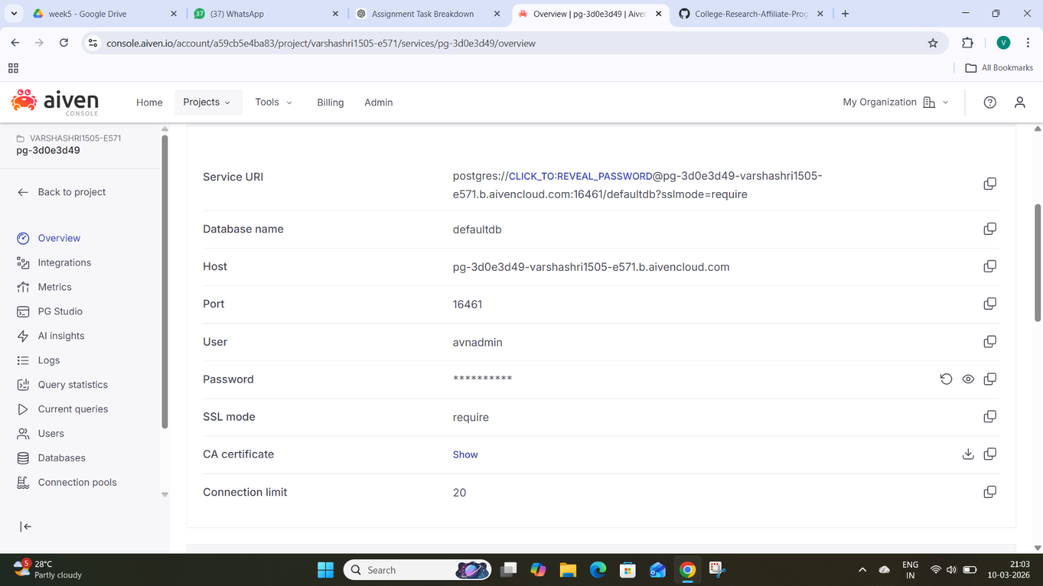
- SSL Mode: require

1.2 Configure Backend Environment
What I Did:
- Created a .env file inside the backend/ directory
- Stored all database credentials securely

Purpose:
- To securely connect backend (FastAPI) with PostgreSQL database
- Avoid hardcoding sensitive credentials in code

1.3 Test Database Connection
What I Did:
- Verified database connection
Output:
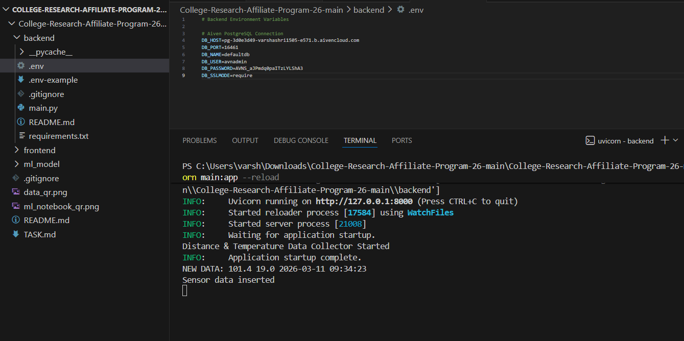

Task 2: Backend API Modifications
2.1 Understand Existing APIs
- Reviewed the existing APIs in backend/main.py.
- Understood how sensor data is fetched using /sensor-data.
- Understood how tank parameters are stored using /tank-parameters.

2.2 Add New API Endpoints
Prediction Endpoint
- Implemented /api/v1/predict API.
- Loaded the trained LSTM model using TensorFlow.
- Took distance and temperature as input.
- Returned predicted activity and confidence score.

Model Info Endpoint
- Created /api/v1/model-info API.
- Returned model details like:
  - Model type (LSTM)
  - Version
  - Accuracy
  - Classes

Predictions History Endpoint
- Created /api/v1/predictions-history API.
- Fetches past prediction results from database.
- Returns data with timestamps.

2.3 Create Predictions Table
- Added a new table predictions in database.
- Table stores:
  - node_id
  - distance
  - temperature
  - prediction
  - confidence
  - timestamp

2.4 Integrate ML Model into Backend
- Placed trained .h5 model inside saved_models/.
- Installed TensorFlow in backend.
- Loaded model at server startup.
- Used model for real-time predictions.
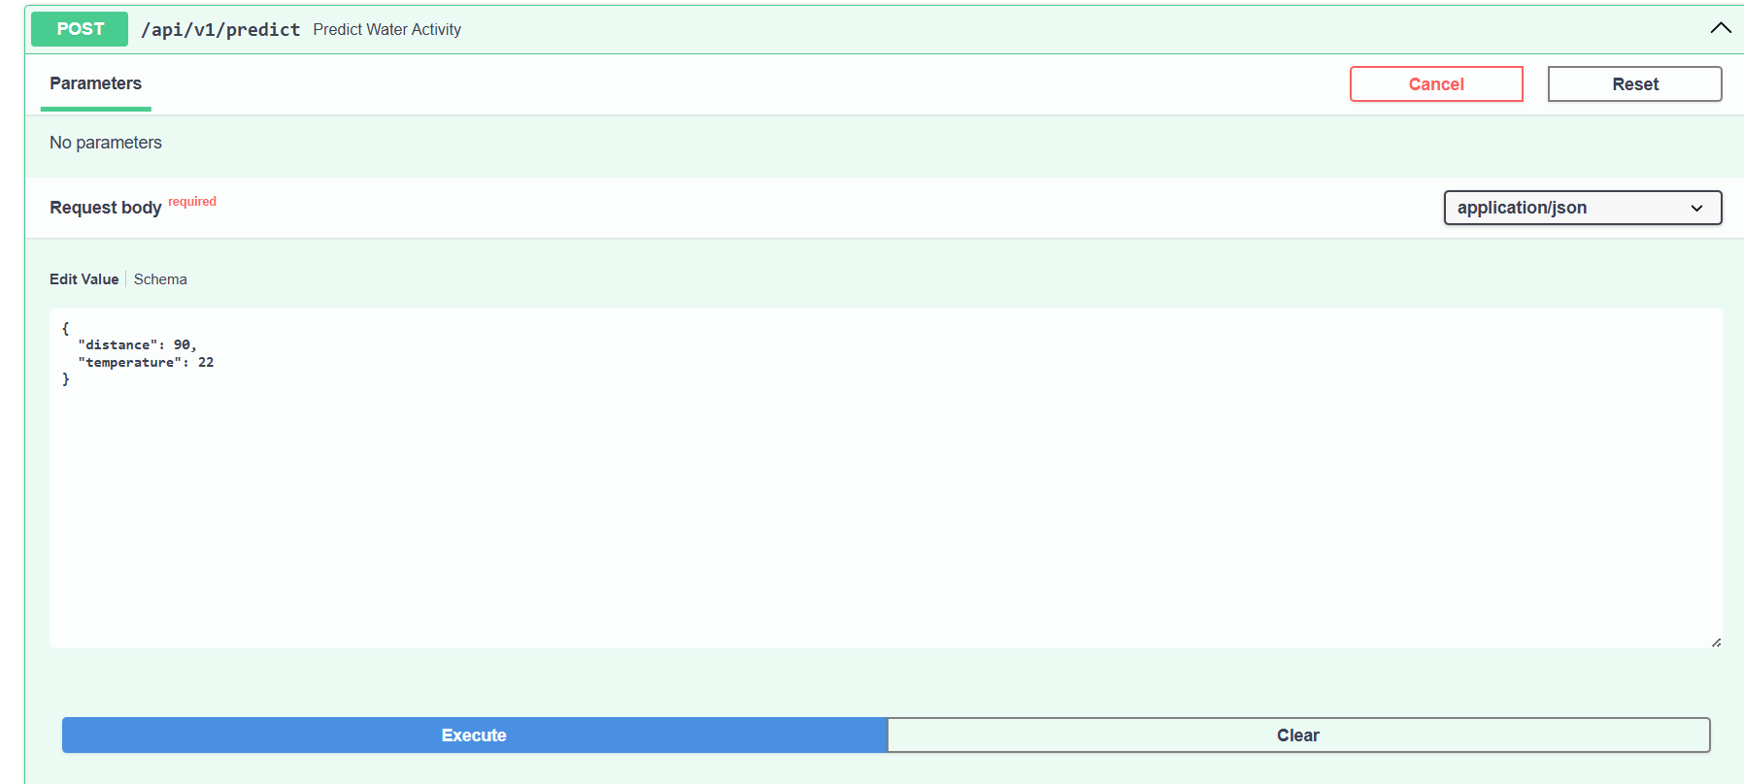
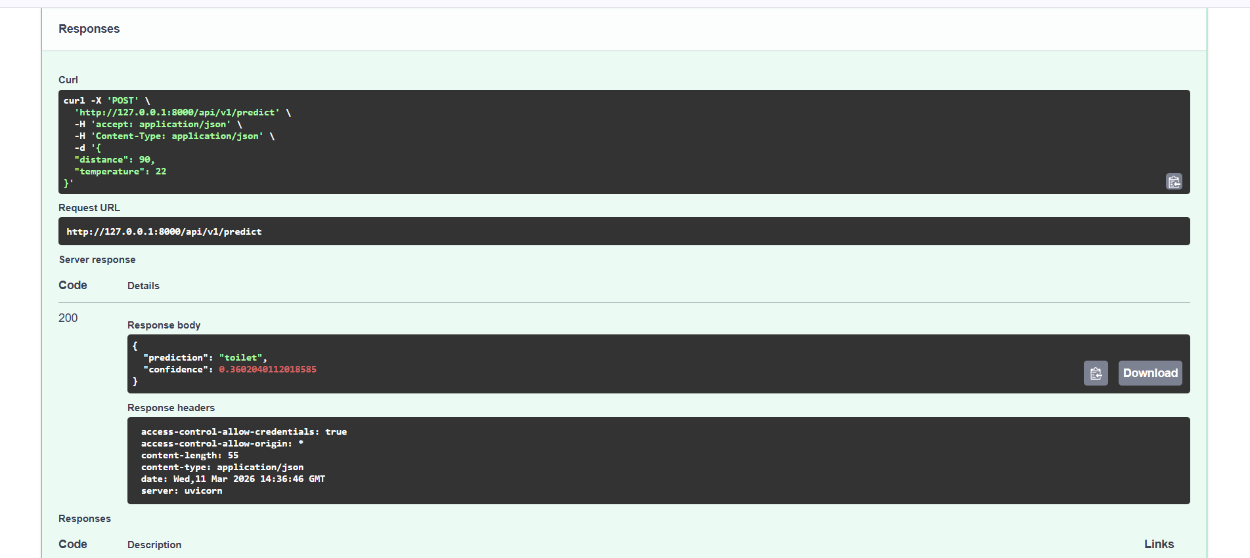
- Screenshot of /api/v1/predict endpoint working
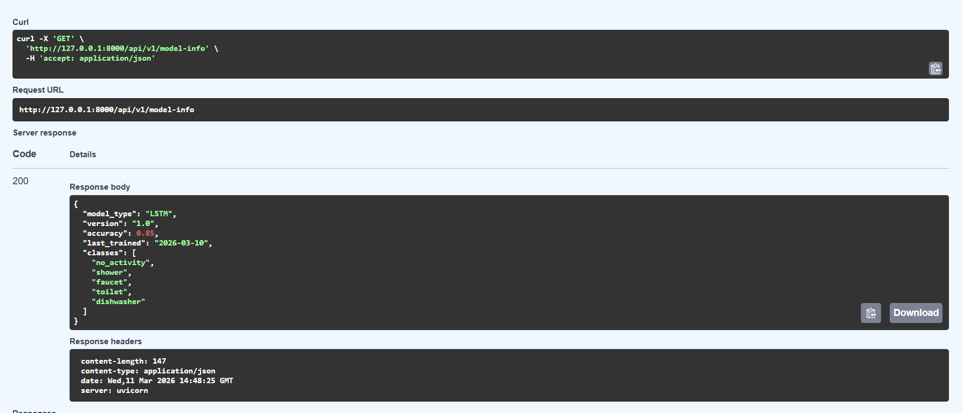
- Screenshot of /api/v1/model-info endpoint response

- Code snippet of your prediction implementation

from tensorflow.keras.models import load_model
import numpy as np

# Load ML model at startup
ml_model = load_model("saved_models/LSTM_model.h5")

labels = ["no_activity","shower","faucet","toilet","dishwasher"]
#Prediction API
@app.post("/api/v1/predict")
async def predict_water_activity(data: dict):

try:
distance = float(data["distance"])
temperature = float(data["temperature"])

# model expects only 2 features
input_data = np.array([[distance, temperature]])
input_data = input_data.reshape((1,1,2))

prediction = ml_model.predict(input_data)

predicted_class = int(np.argmax(prediction))
confidence = float(np.max(prediction))

labels = ["no_activity","shower","faucet","toilet","dishwasher"]

result = labels[predicted_class]

return {
"prediction": result,
"confidence": confidence
}

except Exception as e:
return {"error": str(e)}
#Model Info API
@app.get("/api/v1/model-info")
async def get_model_info():

return {
"model_type": "LSTM",
"version": "1.0",
"accuracy": 0.85,
"last_trained": "2026-03-10",
"classes": [
"no_activity",
"shower",
"faucet",
"toilet",
"dishwasher"
]
}
#Predictions History API
@app.get("/api/v1/predictions-history")
async def get_predictions_history(limit: int = 100):

conn = get_connection()
cur = conn.cursor()

cur.execute("""
SELECT distance, temperature, prediction, confidence, created_at
FROM predictions
ORDER BY created_at DESC
LIMIT %s
""",(limit,))

rows = cur.fetchall()

cur.close()
conn.close()

result = []

for r in rows:
result.append({
"distance": r[0],
"temperature": r[1],
"prediction": r[2],
"confidence": r[3],
"created_at": r[4]
})

return result

Outcome
- Successfully added new APIs.
- ML model integrated with backend.
- Predictions working correctly

Task 3: ML Model Enhancement

3.1 Explore Existing Models
I explored the machine learning notebooks available in the ml_model/ directory, including the main training notebook and visualization notebook. These notebooks helped me understand how different models such as LSTM, CNN, and GRU were trained using sensor data like distance and temperature. I also analyzed how the model predicts water usage activities such as shower, faucet, and toilet based on time-series data.

3.2 Hyperparameter Tuning
I modified the LSTM model architecture by increasing the number of layers and units, and introduced dropout layers to reduce overfitting. I also used the Adam optimizer with a learning rate of 0.001 to improve convergence during training.

Output
After tuning the model, the modified LSTM achieved an accuracy of 84.23%, showing improvement in learning stability compared to the baseline model. The addition of layers and dropout helped the model generalize better on unseen data.

3.3 Training Experiments
I conducted multiple experiments using different models and configurations. The results were recorded in a training log table where parameters like layers, units, dropout, learning rate, and epochs were varied.
Output
From the experiments, the CNN model achieved the highest accuracy of 86.43%, followed closely by the GRU model with 86.10% accuracy, while the improved LSTM achieved 84.23% accuracy. This shows that CNN and GRU models performed better for this dataset compared to LSTM.
Additionally, from the overall comparison:
- Random Forest achieved the highest accuracy of 99.37%
- KNN achieved 98.42% accuracy
- Deep learning models performed slightly lower but are more suitable for sequence-based data
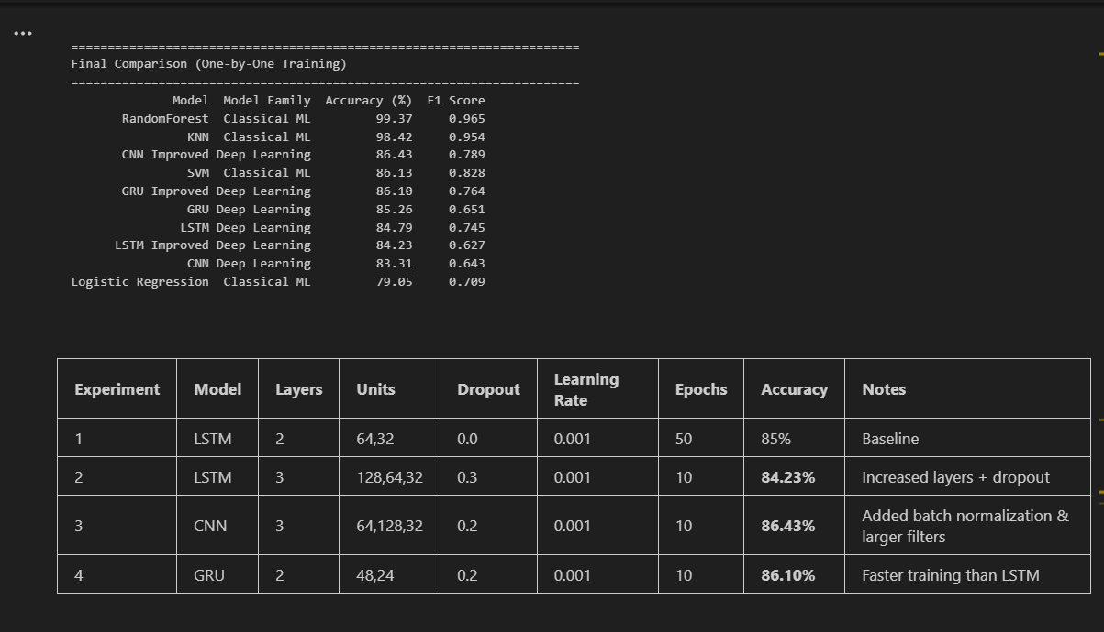

3.4 Model Performance Analysis
I analyzed the training and validation accuracy and loss graphs to understand model behavior.
Output
The training accuracy gradually increased over epochs, while validation accuracy showed slight fluctuations but remained stable overall. The training loss consistently decreased, indicating proper learning, while validation loss had minor variations, suggesting a small amount of overfitting but still acceptable performance.
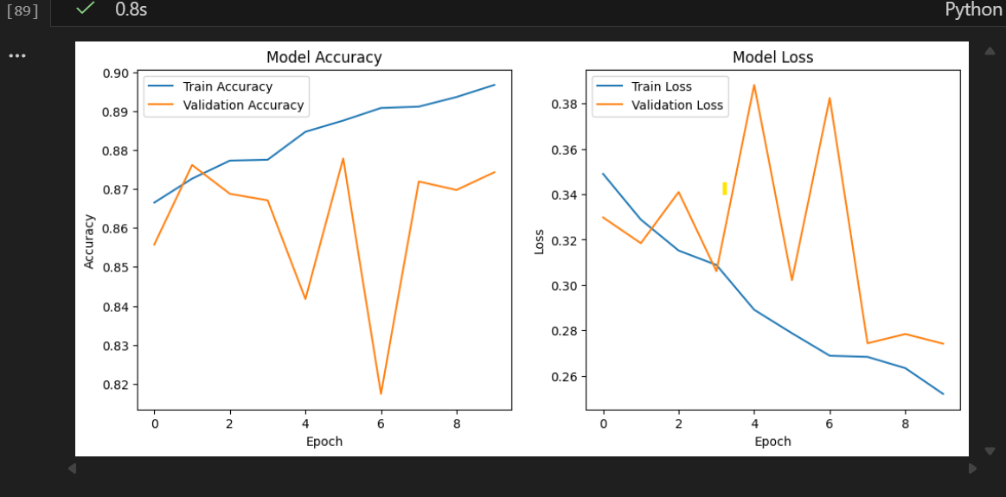

3.5 Export Best Model
After comparing all models, I selected the best performing deep learning model and saved it for backend integration.
Output
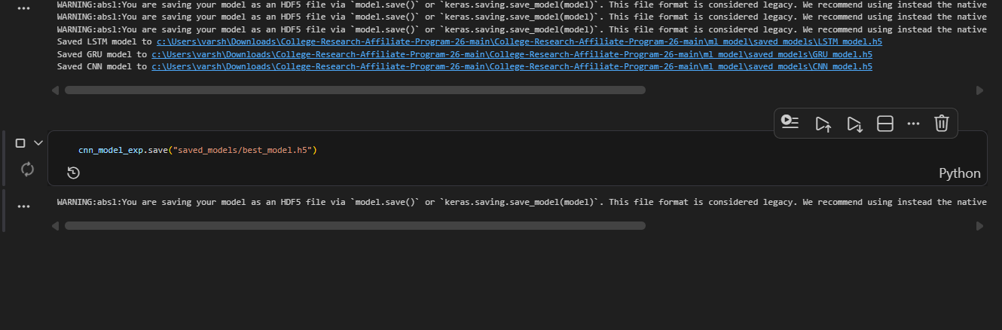
The trained models including LSTM, CNN, and GRU were successfully saved in the saved_models/ folder, and the best model was stored as best_model.h5, which is used later in the backend for prediction.

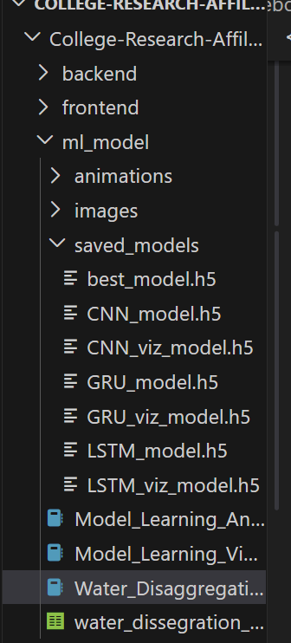

Final Outcome
Through multiple experiments and tuning, I successfully improved the model performance and identified the best model for prediction. The final model was saved and prepared for integration into the backend API to enable real-time water activity prediction.

Task 4: Frontend Enhancements
4.1 Add College Branding
I customized the frontend to match college branding by updating the logo and theme colors. The college logo was added to the public assets and integrated into the navigation bar. Additionally, primary, secondary, and accent colors were defined in CSS and applied across components like navbar and sidebar to maintain a consistent design.
Output
After applying branding changes, the dashboard displayed the college logo and theme colors consistently across all pages, giving the application a professional and personalized appearance.
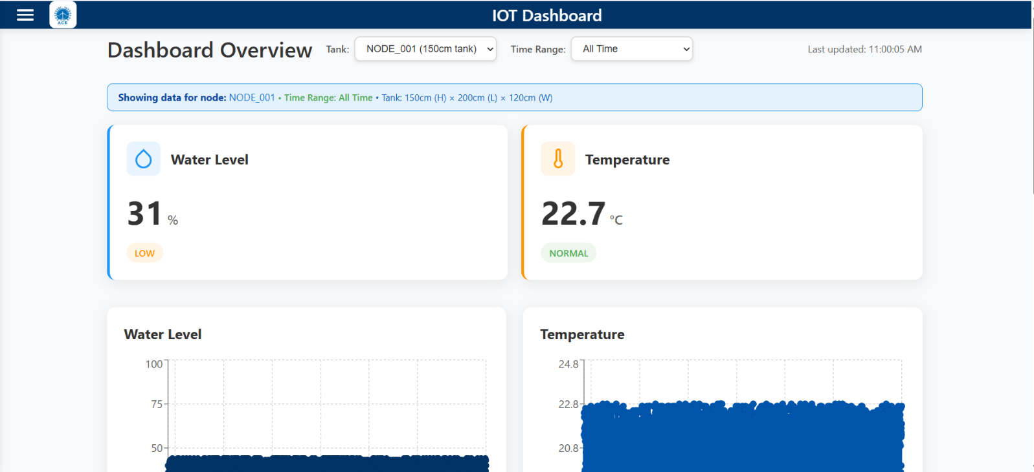

4.2 Create Prediction Page
I created a new Prediction page in the frontend to allow users to input sensor data such as distance and temperature. The page fetches model information from the backend and sends user input to the prediction API to get results. The prediction output along with confidence is displayed on the UI.
Output
The Prediction page successfully accepts user input and displays predicted water activity along with confidence, making the system interactive and user-friendly.
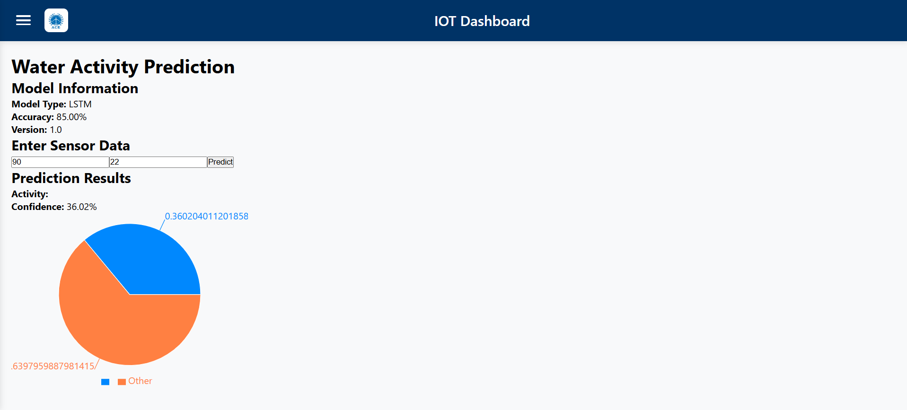

4.3 Add Route for Prediction Page
I added routing for the Prediction page in the main application and included a navigation link in the sidebar so users can easily access it.
Output
The Prediction page is now accessible through the sidebar navigation, enabling smooth user interaction between dashboard and prediction features.

4.4 Modify Existing Charts
I enhanced the existing charts on the Home page by adding new features such as prediction-based visualization and real-time indicators. I also updated chart colors to match the selected theme and added animations for better user experience.
Output
The updated charts now provide better visualization of sensor data and predictions, with smooth animations and consistent styling, improving overall dashboard readability.

4.5 Add Custom Charts
I implemented additional charts such as activity timeline and prediction distribution using Recharts. These charts help in visualizing patterns in water usage and prediction results more effectively.

Output
The newly added charts provide deeper insights into water activity patterns and prediction results, making the dashboard more informative and visually appealing.
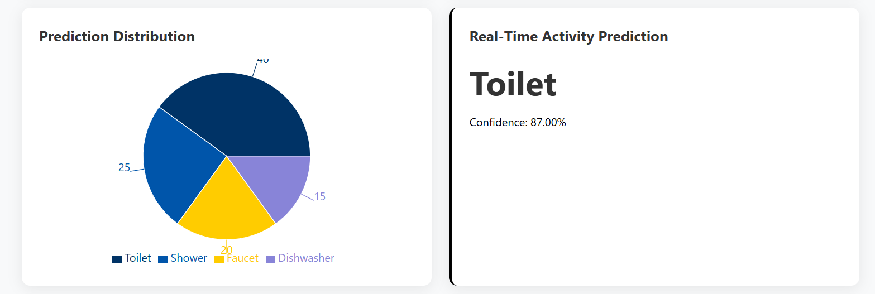

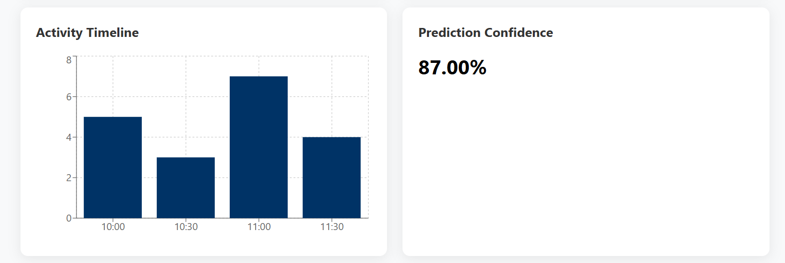
Final Outcome
The frontend was successfully enhanced with improved UI, branding, and interactive features. The integration with backend APIs allows real-time prediction and visualization, resulting in a complete and user-friendly dashboard system.

Task 5: Cloud Deployment

5.1 Prepare for Deployment
Before deploying the application, both backend and frontend were configured for production.
a) Backend Preparation
All required dependencies such as FastAPI, Uvicorn, PostgreSQL driver, TensorFlow, NumPy, and other libraries were included in the requirements.txt file to ensure smooth deployment.
b) Frontend Preparation
The frontend configuration was updated to use environment variables for API communication. This allows the frontend to connect to the deployed backend instead of localhost.
Output:
The application was successfully configured for production with all dependencies and environment variables properly set.

5.2 Deploy Backend to Render
The backend was deployed using Render cloud platform.
Steps followed:
- Code pushed to GitHub
- Created a new Web Service in Render
- Configured:
  - Root Directory: College-Research-Affiliate-Program-26-main/backend
  - Build Command: pip install -r requirements.txt
  - Start Command: uvicorn main:app --host 0.0.0.0 --port $PORT
- Added environment variables from .env
- Deployed successfully
Output:
The backend API was successfully deployed on Render and is live, handling requests from the frontend.
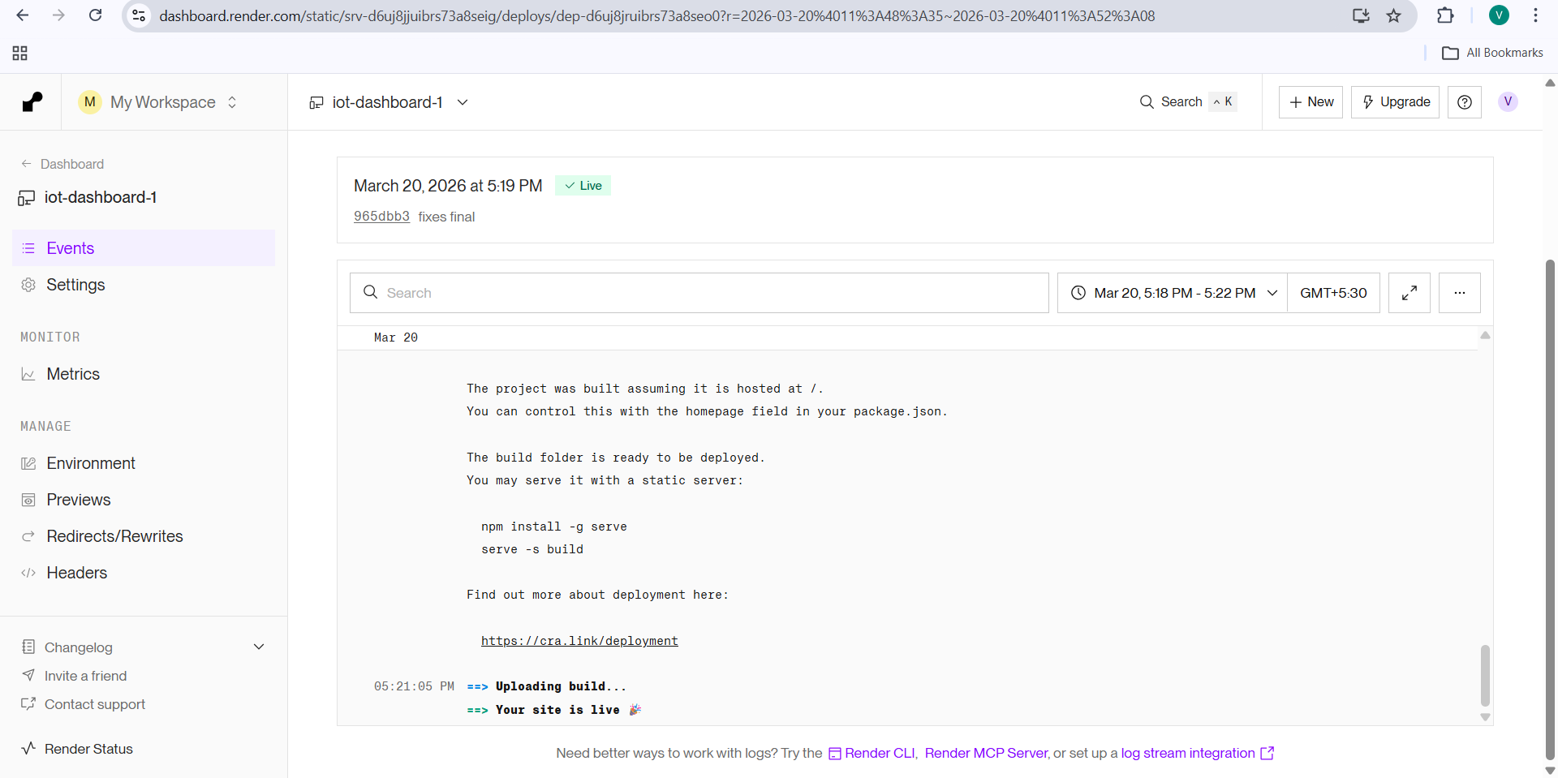

5.3 Deploy Frontend
The frontend was prepared and deployed using Vercel.
Steps followed:
- Created .env.production file with backend URL
- Built the frontend using npm run build
- Deployed using Vercel platform
Output:
The frontend application was successfully deployed and connected to the live backend API.
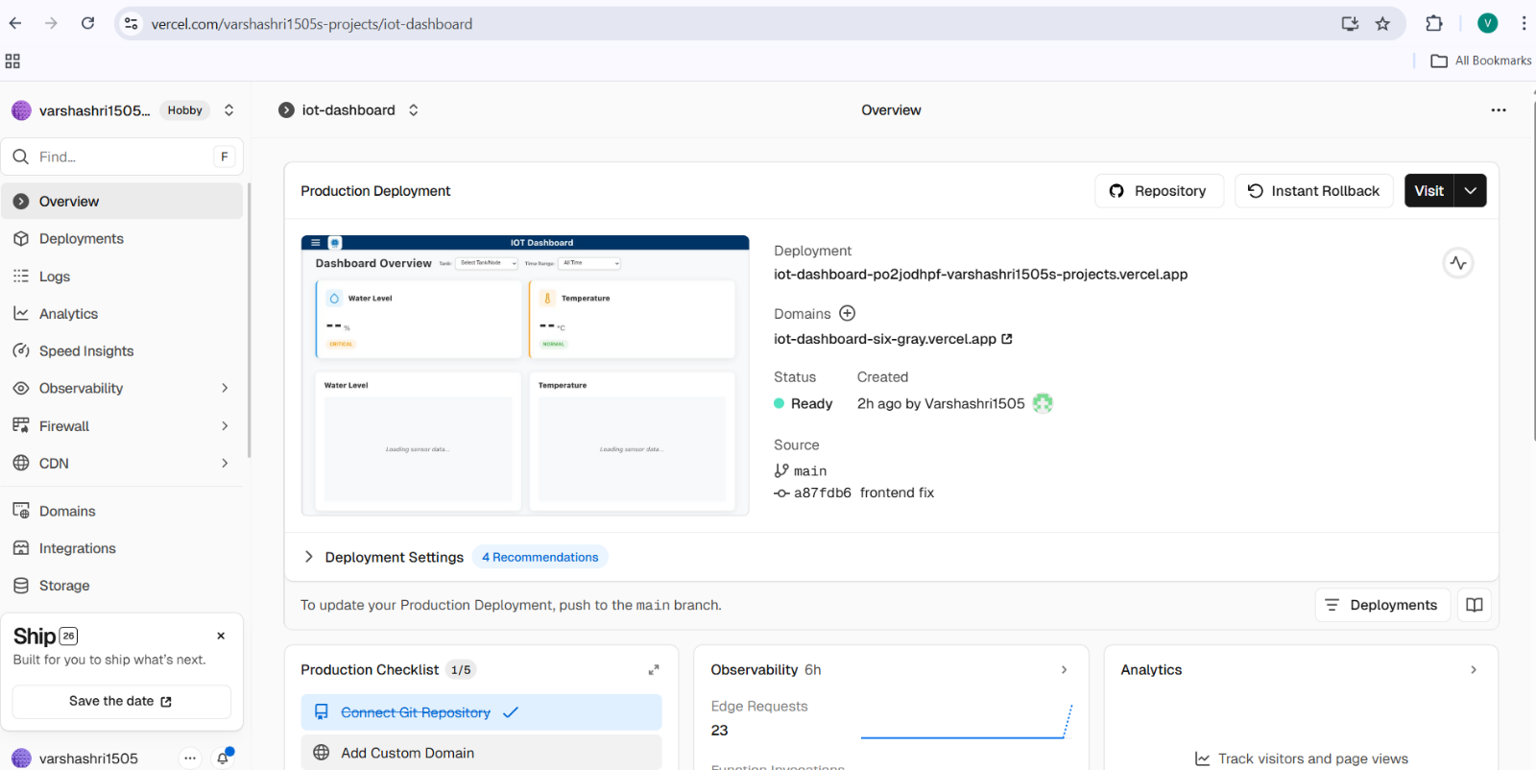
5.4 Test Deployed Application
After deployment, the application was tested to ensure proper functionality.
Testing included:
- Opening deployed frontend URL
- Verifying dashboard loading
- Checking real-time data display
- Testing prediction functionality
- Ensuring backend API integration
Output:

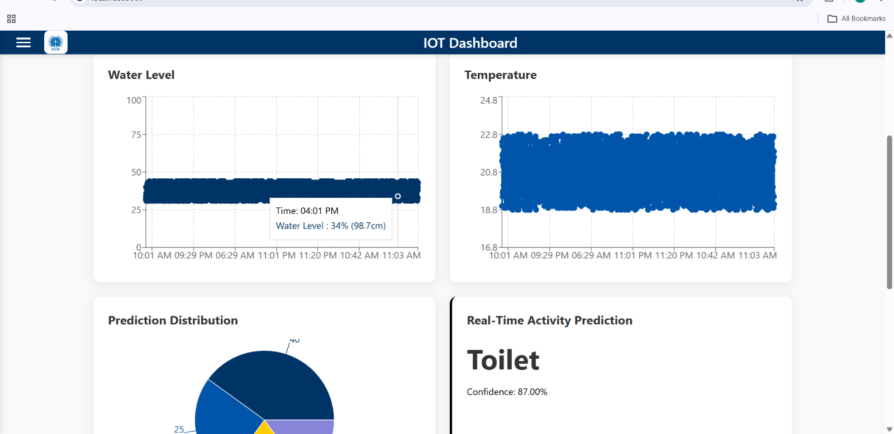
The deployed application works successfully, displaying real-time sensor data, charts, and prediction results without any issues.
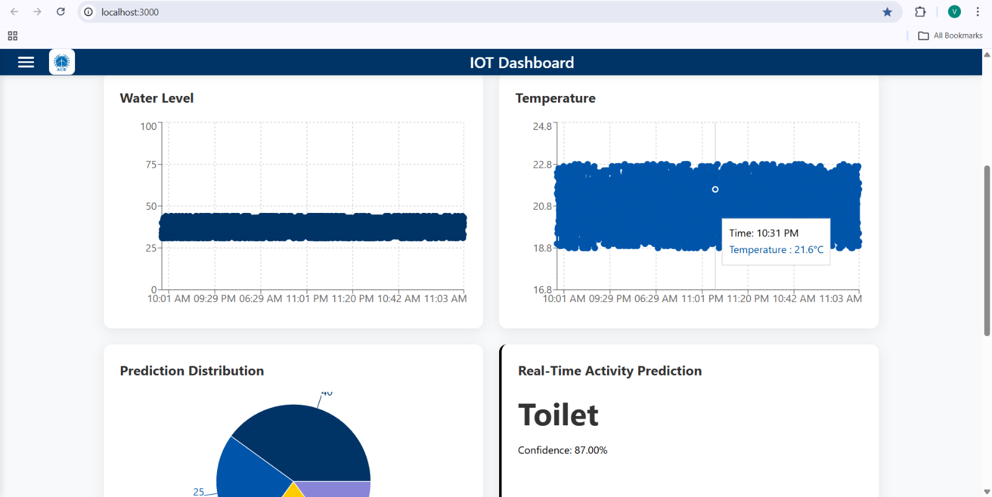

- Backend Deployed Link:
https://iot-dashboard-3217.onrender.com/docs

- Frontend Deployed Link:
https://vercel.com/varshashri1505s-projects/iot-dashboard
Outcome
The complete IoT Dashboard system was successfully deployed to the cloud. The backend API is hosted on Render and the frontend is hosted on Vercel, enabling real-time data visualization and prediction from anywhere. The deployment ensures scalability, accessibility, and practical usability of the system.
Conclusion:
This project successfully developed an IoT-based water monitoring and prediction system using FastAPI, React, and machine learning models. Real-time sensor data was visualized through an interactive dashboard, and predictions were generated using trained models. The system was deployed on cloud platforms (Render and Vercel), making it accessible and functional. Overall, the project provided practical experience in full-stack development, ML integration, and cloud deployment.

